1. **Methodology:**
2. **Block Diagram:**

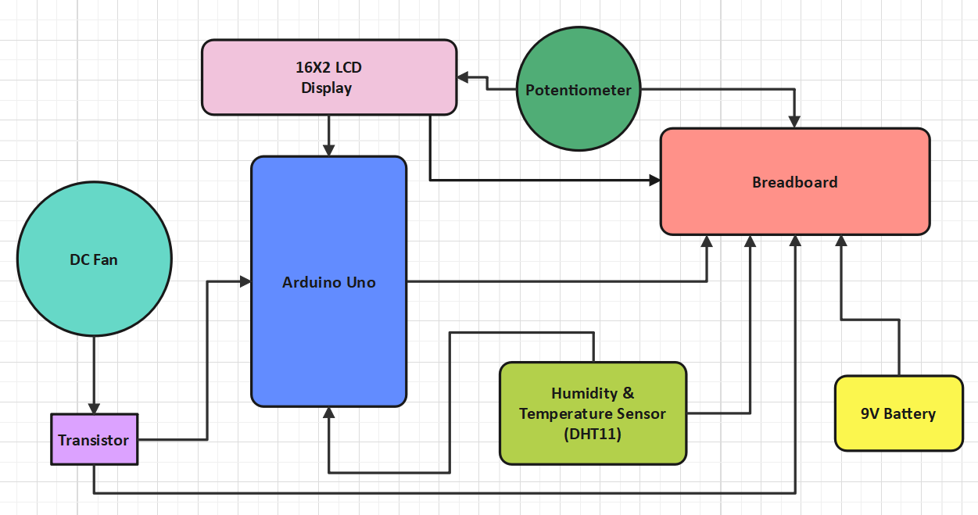

**Fig.1. Block Diagram of Temperature Controlled DC Fan**

This block diagram gives us an idea of ​​the components of the respective project and also shows how the components are connected to each other.

1. **Circuit Diagram:**

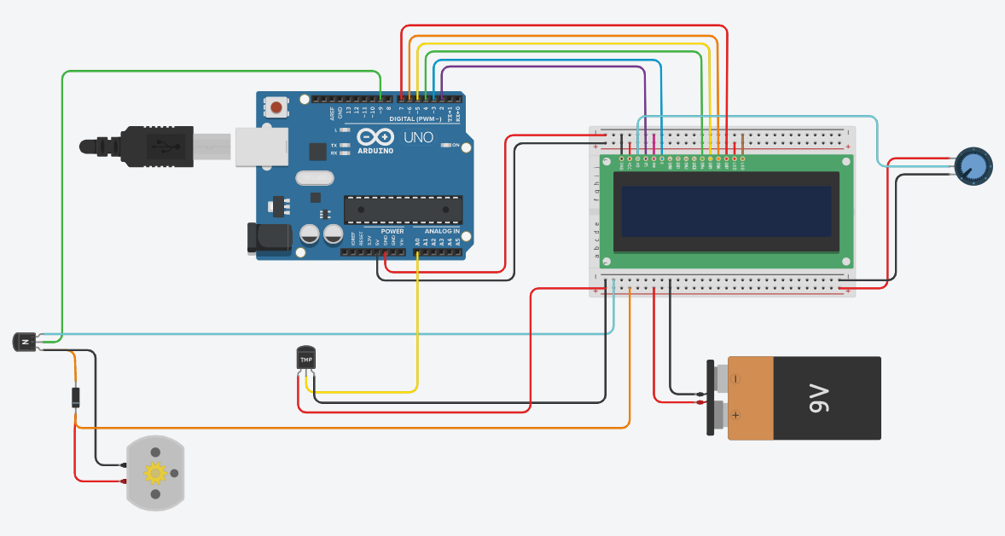

**Fig.2. Circuit Diagram of Temperature Controlled DC Fan**

The schematic above shows the 3D details of the hardware simulation. Here you can see what the components look like and the detailed connections between these components.

1. **Flowchart:**

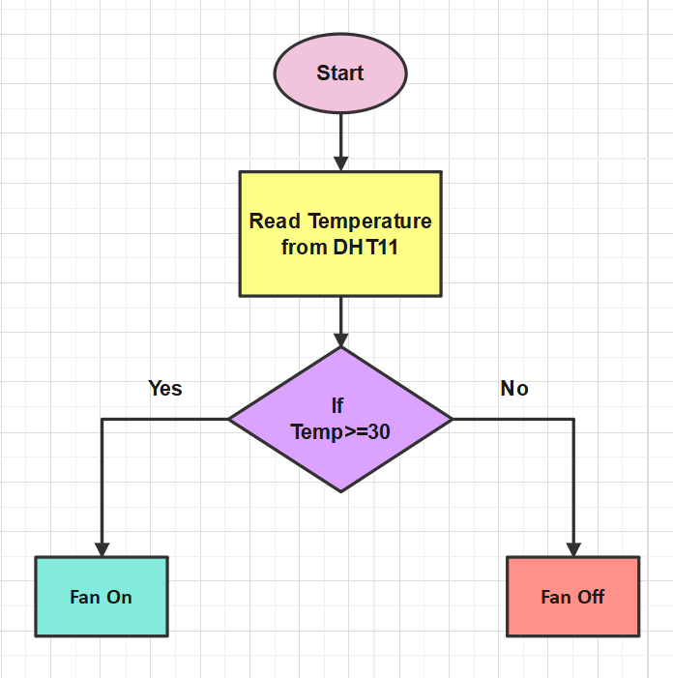

**Fig. 3. Flowchart of Temperature Controlled DC Fan**

The flowchart showing the workflow of the deployed project.

1. **Description:**

In this Arduino based project we have created a temperature controlled DC fan. With this project, we will be able to adjust the fan speed in our home or office based on the ambient temperature, and display temperature changes and fan status on a 16x2 LCD. In this project we used Arduino UNO board, LCD display, DHT11 sensor module and DC fan.

This estimation project works in several phases. The temperature is detected by the humidity and temperature sensor, namely the DHT11. Then another part reads the output of the DHT11 sensor module and extracts the temperature value to an appropriate number in degrees Celsius and controls the fan. And finally, the system displays the temperature on the LCD screen and indicates whether the fan is on or off.

1. **Required instruments:**

|  |  |  |
| --- | --- | --- |
| **NO.** | **COMPONENT NAME** | **QUANTITY** |
| 1. | Arduino Uno R3 | 1 |
| 2. | DHT11 Humidity &Temperature Sensor | 1 |
| 3. | DC Fan | 1 |
| 4. | LCD 16X2 | 1 |
| 5. | NPN Transistor | 1 |
| 6. | Diode | 1 |
| 7. | Potentiometer | 1 |
| 8. | 9V Battery | 1 |
| 9. | Breadboard | 1 |
| 10. | Jumper Wires | 23 |

1. **Picture of the implemented project:**

* **Hardware Simulation:**

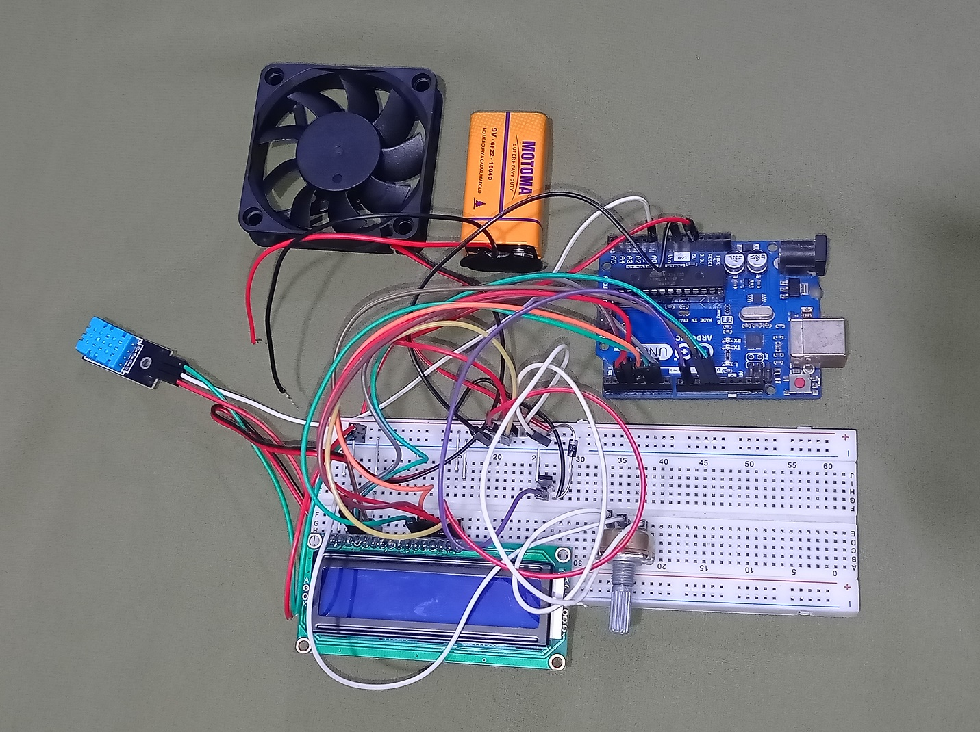

**Fig. 4. Hardware without Battery Connection**

* **If the temperature is below 30 degrees, fan turned off.**

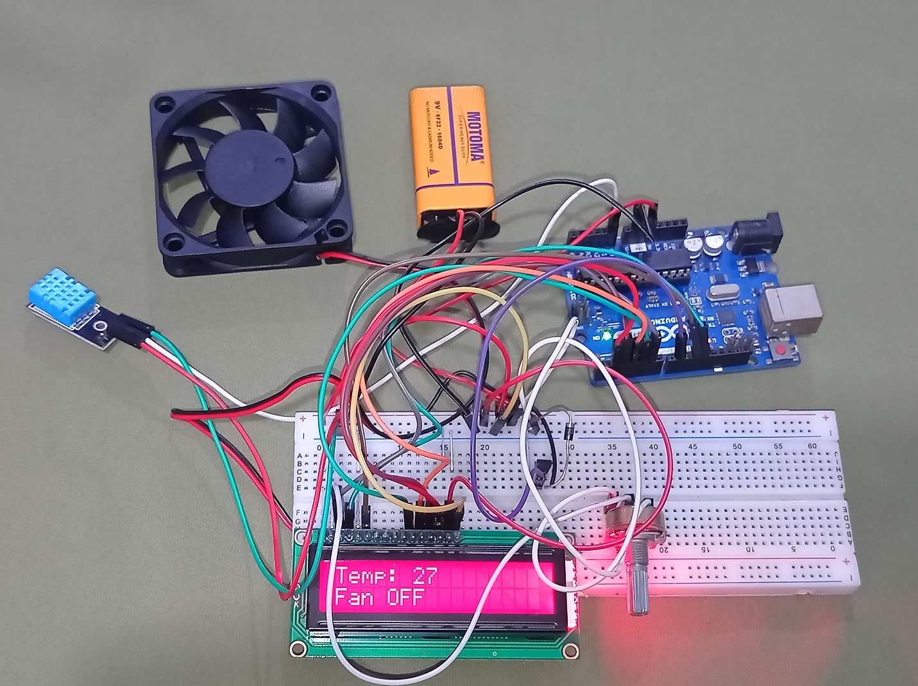

**Fig. 5. Fan is OFF**

* **The fan turns on when the temperature is 30 or more than 30 degrees.**

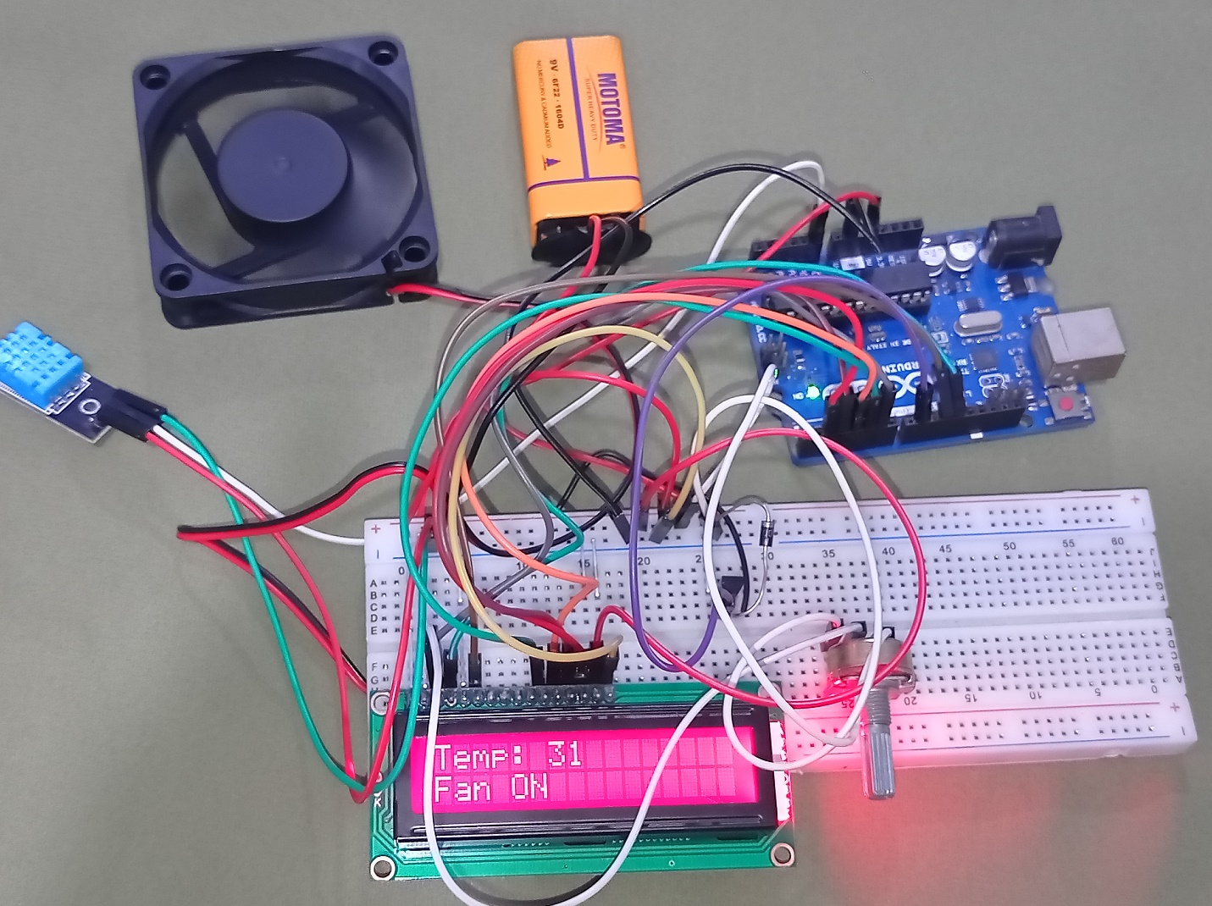

**Fig. 5. Fan is ON**

**10. Reference:**

1. <https://circuitdigest.com/microcontroller-projects/arduino-humidity-measuremen>
2. <https://create.arduino.cc/projecthub/1NextPCB/temperature-controlled-fan-using-arduino-925f23>
3. <https://www.slideshare.net/imraanbracu/automatic-room-temperature-controlled-fan-using-arduino-uno-microcontroller>

**11. Appendix:**

1. <https://github.com/sanjidaaaziz/Temperature-controlled-DC-fan.git>